CAPSTONE PROJECT:

Course Code

Report Outlining Development of Fitness Freelancer Webpage

Author: Trevor Davies

Submitted: Date

Contents

Introduction 3

Wireframe Diagram and Planning Documents 3

Technology Stack and Rationale 3

Testing Methods 3

Challenges Faced 3

Lessons Learned 3

Final Recommendations 3

Annex A 4

## What does this project offer?

This project resulted in the creation of the Fitness Freelancer webpage. This website will be used by the business that the author plans to start with a partner. This website will sell Business to Business copy (advertisements, added contented, tips, emails, promotions) to small private gyms as well as provide a means to attract customers, gather feedback and communicate with clients.

## Wireframe Diagram and Planning Documents

Annex A contains the project proposal (planning document) along with the initial wireframe document. Annex B contains the wireframe document after the project was completed.

## Technology Stack and Rationale

Ddd

## Testing Methods & Security

Ddd

## Did the project adhere to the initial design?

Name changed from Wellness Promotions to Fitness Freelaner

## Is this project up to industry standards?

## Challenges Faced

Dd

## Lessons Learned

Dd

## Final Recommendations

Ddd

## Annex A: Project Proposal and Initial Wire Frame Diagram

Project Proposal for Capstone Project

For Trevor Davies

11 August 2025

My proposal is to create a website for a business I plan to start with a partner. This website will sell Business to Business copy (advertisements, added contented, tips, emails, promotions) to small private gyms. The Wireframe Diagram outline for this project is found in Figure 1. Figure 1 will replace “Project Outline” and “Must Haves” contained in the course instructions. My final product will adhere to the “Project Submission” requirements contained in the course instructions.

The benefit of this proposal is that I will be working on a project I intend to implement. Therefore, it will provide me with motivation and interest to create a secure, useful and orderly website.

Below are how this project addresses the key points you stressed in your 21 Mar 2025 Direct Message to me in the C4V Slack.

1. *What does this project offer, or what service does it provide?*

See first paragraph above.

1. *Is it secure?*

The project will ensure the that input validation is respected to reduce the chances of a cyber infiltration/attack.

1. *Did the project adhere to your initial design and follow your documentation?*

I will start with an initial design of the website (see attached wire frame diagram). I will then use an iterative process (seeking feedback from my partner) as the project progresses. I will keep notes indicating any design changes.

1. *Is this project up to industry standards?*

The plan is to have this project close industry standards as I plan to use it for our company after some polishing and extra help where needed.

## Annex B: Final Wire Frame Diagram

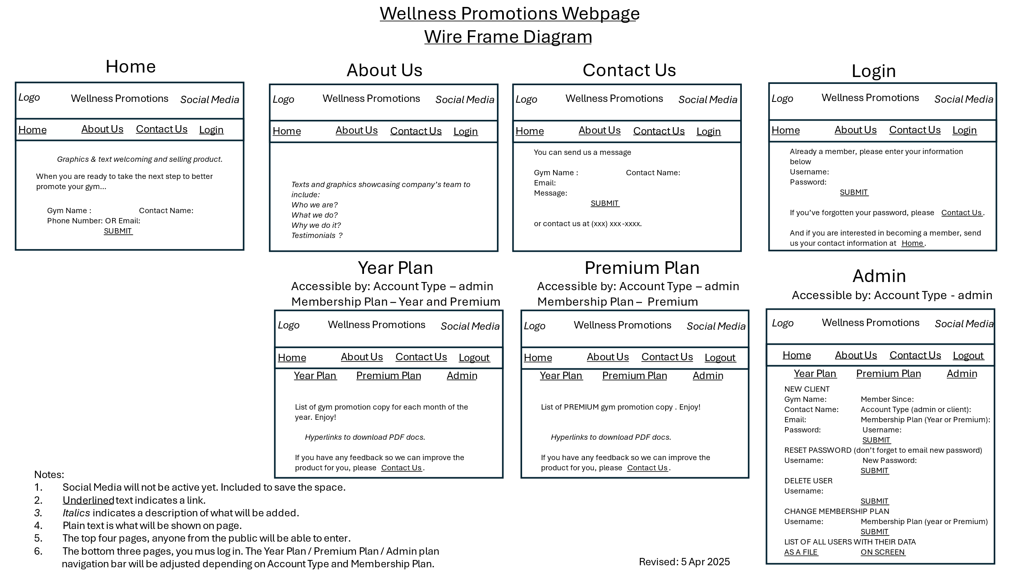

Figure 1: Wireframe Diagram for my project.